Independent-Samples t-Test (Social Skills) – Answer Key
A psychologist is examining the influence of an older sibling in the development of social skills. A sample of 19 three-year-old children is obtained. Half of these children had no siblings and the others had at least one older sibling who is within 5 years of the child’s age. The social skills score for each child is listed in the table. Do these data indicate that having an older sibling has a significant effect on the development of social skills?

Step 1. State your hypotheses.
a. Is it a one-tailed or two-tailed test?
Two-tailed

b. Research hypotheses
H_{A}: Children who have an older sibling will differ from those who do not have an older sibling on
social skills.

H₀: Children who have an older sibling will NOT differ from those who do not have an older
sibling on social skills.

c. Statistical hypotheses
H_{A}: μ_{sib} - μ_{no sib} ≠ 0

H₀: μ_{sib} - μ_{no sib} = 0

Step 2. Set the significance level ➔ α = .05 Determine t_{crit}. t_{crit} = ± 2.110

Step 3. Compute the appropriate statistical test.
Older  Sibling  (X₁) |  | X – | (X –)²
5 | 7.2 | -2.2 | 4.84
6 |  | -1.2 | 1.44
7 |  | -0.2 | 0.04
8 |  | 0.8 | 0.64
10 |  | 2.8 | 7.84
7 |  | -0.2 | 0.04
8 |  | 0.8 | 0.64
7 |  | -0.2 | 0.04
6 |  | -1.2 | 1.44
8 |  | 0.8 | 0.64
ΣX₁ = 72 |  |  | Σ(X –)² = 17.6
= 7.2
n₁ = 10

No  Sibling  (X₂) |  | X – | (X –)²
3 | 4.333 | -1.333 | 1.777
6 |  | 1.667 | 2.779
4 |  | -0.333 | 0.111
5 |  | 0.667 | 0.445
4 |  | -0.333 | 0.111
3 |  | -1.333 | 1.777
2 |  | -2.333 | 5.443
7 |  | 2.667 | 7.113
5 |  | 0.667 | 0.445
ΣX₂ = 39 |  |  | Σ(X –)² = 20.001
=4.333
n₁ = 9

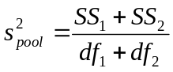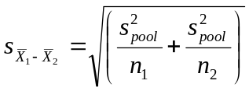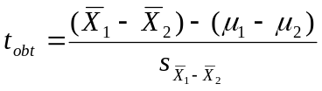

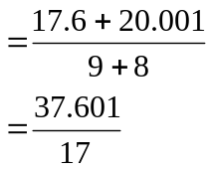
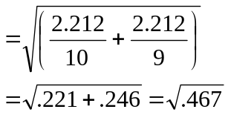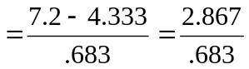

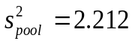
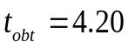
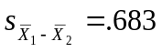

Step 4. Make a decision. Determine whether the value of the test statistic is in the critical region. Draw a picture. Label t_{crit} and t_{obt}.
Is t_{obt} in the critical region? Yes
Should you reject or retain the H₀? reject

t_{obt} = 4.20

t_{crit} = -2.110 t_{crit} = +2.110

Step 5. Report the statistical results.

t(17) = 4.20, p < .05

Step 6. Write a conclusion.

The social skills scores of three-year-old children who have an older sibling (M = 7.2) are significantly higher than those who do not have an older sibling (M = 4.33), t(17) = 4.20, p < .05.

Step 7. Compute the estimated d.

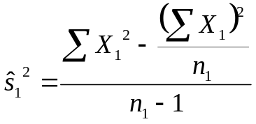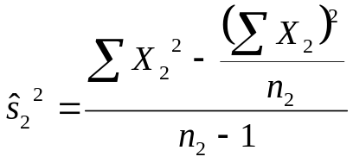
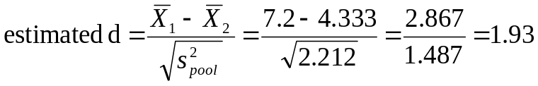

Step 8. Compute r² and write a conclusion.

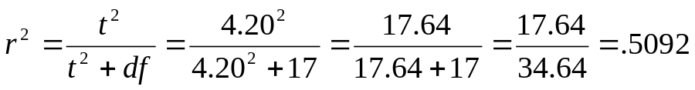
The presence of an older sibling accounts for 50.85% of the variance in children’s social skills.

